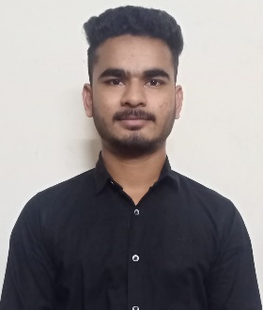RAJU SURAGONI

H.no:5-63/2 CHANDLAPUR, SIDDIPET, TELANGANA, 502276. Ph.no**:** 9985963583

( [rajgoudsrg@gmail.com](mailto:rajgoudsrg@gmail.com) )

# Education

### **Narsimha Reddy engineering college-JNTUH** Hyderabad, Telangana

### B-tech, Electrical & Electronics Engineering **–6.85** 2019 - 2022

### **Indur Institute of Engineering and Technology** Siddipet, Telangana

### Diploma, Electrical & Electronics Engineering **– 76.3%** 2016 - 2019

### **ZPHS chandlapur** Chandlapur, Telangana

### Secondary School of Certificate (10th) **– 7.8** 2016

# Technical Skills

**Front End:** HTML, CSS, Bootstrap, JavaScript, React.js*

**Back End:** Python, Django, rest API

**Databases:** Oracle SQL

# Personal Skills

* Hardworking
* Leadership qualities
* Good communication skills
* Problem solving

# Projects

* **Electrical project**

**Major Project: Power quality enhancement for a grid connected wind turbine energy system-** A four-leg inverter linked to the grid side to infuse the offered power, in addition to function as an energetic power filter mitigating lots existing disruptions as well as boosting power top quality. A four-wire system is thought about with three-phase and also single-phase straight and also nonlinear lots. Throughout the link of the wind generator, the utility-side controller is created to make up the disruptions triggered in visibility of responsive, nonlinear, and/or out of balance solitary and also intra-phase tons, along with giving energetic as well as responsive power as needed. When there is no wind power offered, the controller is meant to boost the power top quality making use of the dc-link capacitor with the power converter connected to the grid.

# Personal Details .

**Father’s name**: Suragoni Thirupathi

**Nationality**: Indian

**Date of Birth**: 20-12-2000

**Languages Known**: English, Telugu

# Declaration

# I hereby declare that all the information rendered by me is true to the best of my knowledge and belief.

**PLACE:** Hyderabad

**DATE:**  **(S. RAJU)**